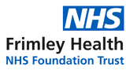

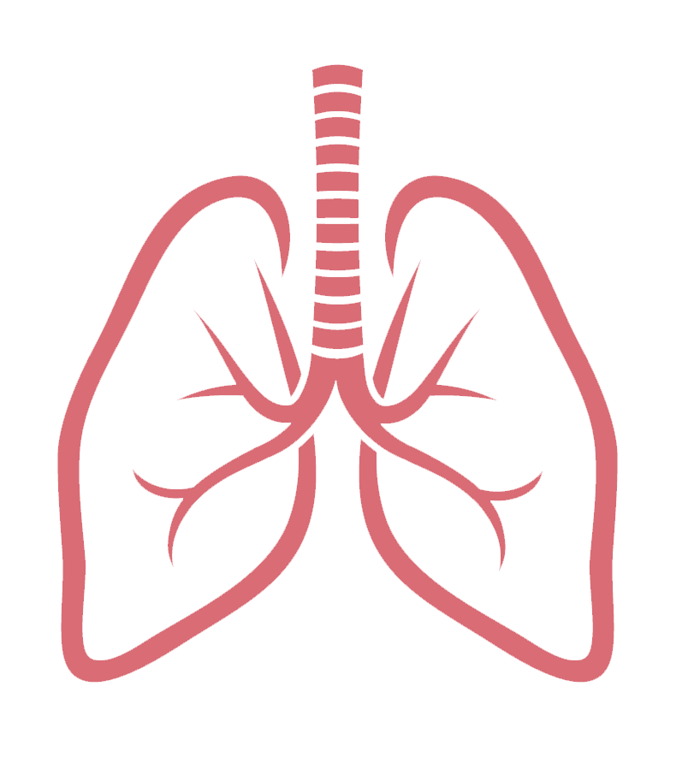
It’s not easy being wheezy

Does your child suffer with wheeze when they have coughs and colds?
Have they been told they have Asthma?
Are you unsure what any of this means?
The Paediatric Respiratory Nursing Team from Frimley Health, along with your local School Nursing team, are offering parent/carer coffee mornings at your child’s school and would like to invite you along to meet the team and other parents to learn more about your child’s symptoms.
Thursday 1st December @ 9am
This will be an informal chat where we can answer any questions or concerns you may have
Please speak to your school to confirm your space
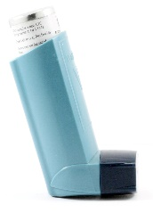


This Photo by Unknown Author is licensed under CC BY-SA-NC

