THAMES VALLEY POLICE
Yr3 - Hate Crime
11.11.24
Apollo class enjoyed having Louise the police officer talk to us about the different roles the police have. The pupils discussed what they thought bullying and hate crime means before she explained to them the correct definition.

PUPIL VOICE
F: Bullying is when you keep hurting the same person.
J: It's hate crime when you hurt somebody just because they have a different colour skin or a different religion.
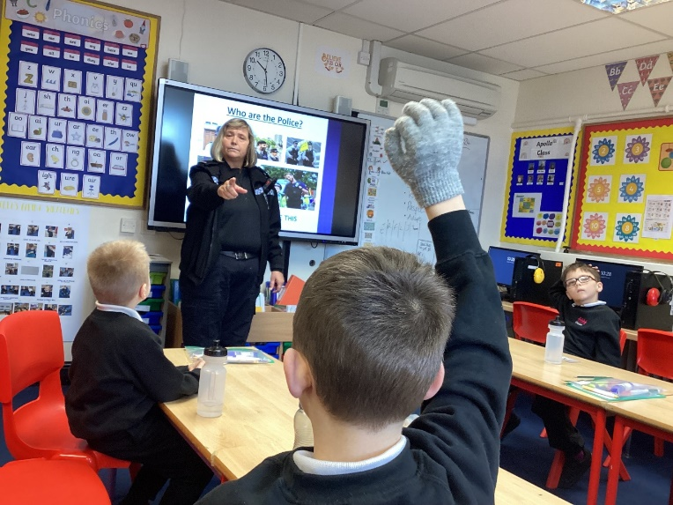
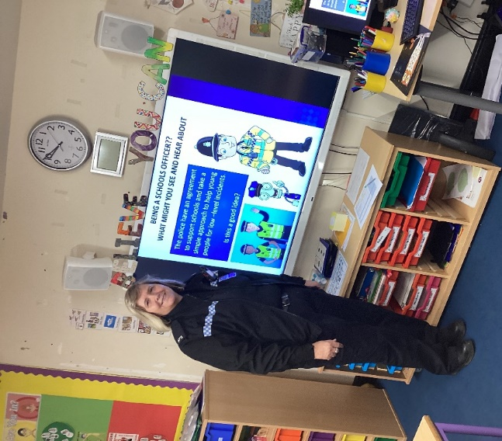
R: It's a hate crime when you hurt somebody just because they have different colour skin to you.



