Pupil Premium Grant 2020-2021
Littledown School | 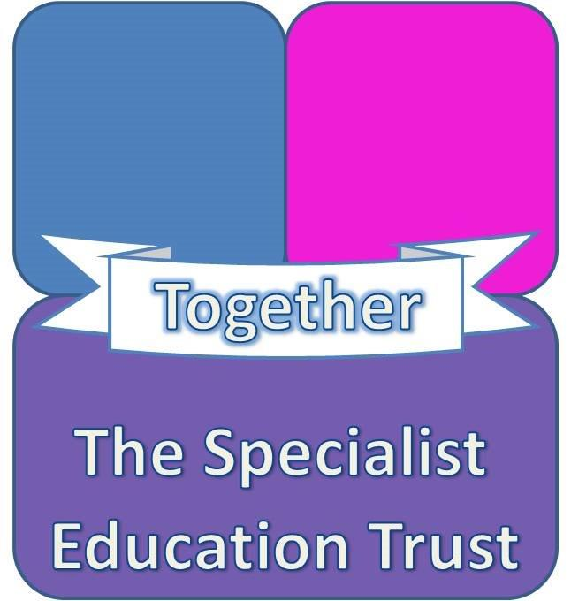
The Pupil Premium Grant, launched by the Government in 2011-12, is additional to main school funding (Dedicated Schools Grant (DSG)). This is allocated to schools as a means to address the current underlying inequalities between children eligible for free school meals (FSM) and their peers by ensuring that funding to tackle disadvantage reaches the pupils who need it most.

The Pupil Premium is allocated to schools to work with pupils who have been registered for free school meals at any point in the last six years (known as ‘Ever 6 FSM’) and for those who have been looked after for 1 day or more, adopted from care or has left care under a special guardianship order, a residence order or a child arrangement order. Historically it also included children of service personnel.
Funding Received:
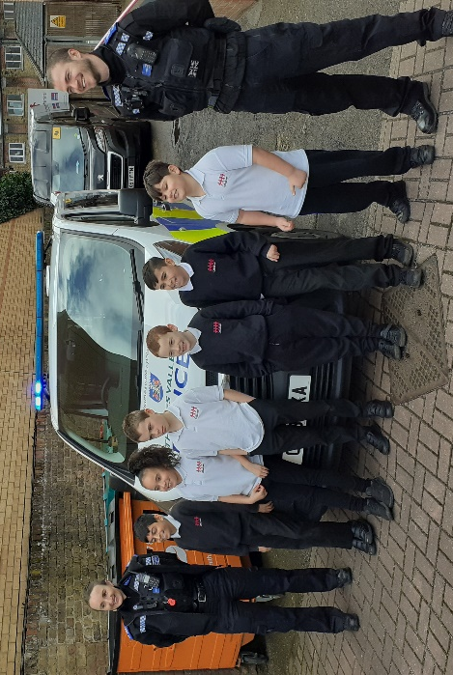 |  | Financial Year | Eligibility basis | Pupils Eligible | Funding per pupil | Total Funding
 |  | 2017-18 | ‘Ever 6’ pupil | 17 | £1,320 | £22440
 |  | 2017-18 | Looked after, adopted or leaving care | 3 (1 part year) | £1,900 | £3493
 |  | 2017-18 | ‘Ever 3’ service children | 0 | £300 | £0
 |  | 2017-18 | Total |  |  | £25933
 |  | 2018-19 | ‘Ever 6’ pupil | 16 | £1,320 | £21120
 |  | 2018-19 | Looked after, adopted or leaving care | 1 | £2,300 | £2300
 |  | 2018-19 | ‘Ever 3’ service children | 0 | £300 | 0
 |  | 2018-19 | Total |  |  | £23420
 |  | 2019-20 | ‘Ever 6’ pupil | 19 | £1320 | £25080
 |  | 2019-20 | Looked after, adopted or leaving care | 3 | £2,300 | £6900
 |  | 2019-20 | ‘Ever 3’ service children | 0 | £300 | 0
 |  | 2019-20 | Total |  |  | £31980
 |  | 2020-21 (Pandemic) | ‘Ever 6’ pupil | 16 | £1345 | £21520
 |  | 2020-21 (Pandemic) | Looked after, adopted or leaving care | 5 | £2345 | £11725
 |  | 2020-21 (Pandemic) | ‘Ever 3’ service children | 0 | £310 | 0
 |  | 2020-21 (Pandemic) | Total |  |  | £33245

Outline of Pupil Attainment Priorities
In making provision for pupils to improve at the correct rate in terms of their educational development the school needs to identify and understand the priorities required to achieve the required outcomes.
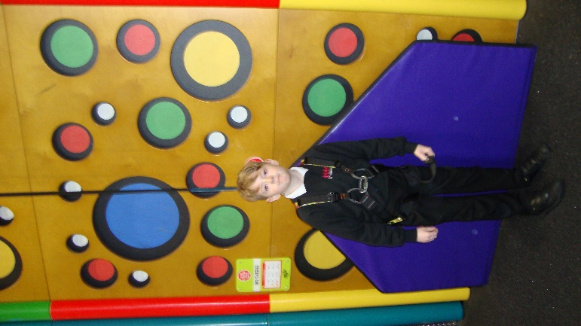 |  | 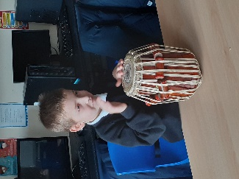 |  | 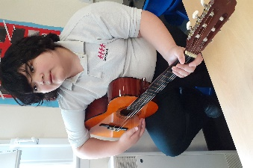
 |  | 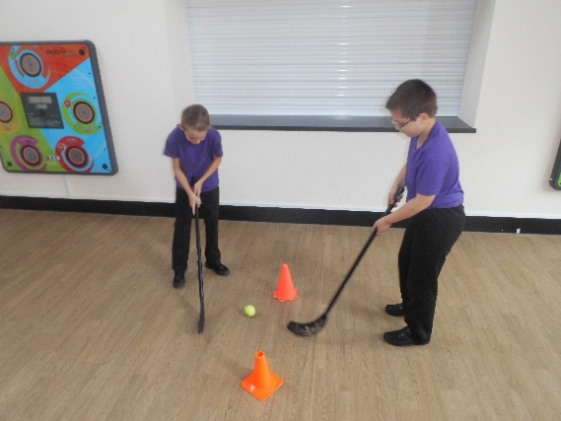
The identification of priorities will be determined by;
- Observing the children and gaining an understanding of their development needs and formulating a programme of interventions and actions to meet them.
- Analysing attainment data (current and historic) including trends and progress at a school, local and national level so that the current benchmark can be identified.
- Undertake a review of the previous plan to address these needs to ascertain their level of success and whether to continue, cease or change how they are delivered.
- Assess the achievement of best value in the delivery of interventions and actions.
- Researching improvements in improving attainment outcomes.

The identification of the appropriate priorities are;
- A variety of therapeutic interventions including; in order to address the emotional issues inhibiting the learning of students.
- Specific SEN resources to support independent learning in class.
- 1:1 programmes targeting specific learning difficulties.
- Social skills workshops (ELSA, Lego Therapy), sports programmes or 1:1 programmes to raise self-esteem.
- Transition work to support pupils transferring between primary and secondary settings, or when reintegrating to a mainstream setting.
- Outreach work to support family with consistently managing behaviour and supporting learning.
- Residential trip, educational visits and after school provision to improve social skills

- It should be noted that the school faced external pressures due to COVID19 and Mar-Apr 20 Lockdown and the Jan 21 Lockdown
Outline of Pupil Premium Usage and Measurement of Outcomes April 2020 / March 2021
Use of Pupil Premium | Amount Allocated  £ | Year Group(s) involved | Nature of support provided | Intended Outcomes of support provided | How the activity will be monitored, frequency, position responsible | How success will be evidenced | Actual Impact of activity.  Will activity continue? Are changes required to improve it? What are they?
Art & drama psychotherapy | £7785  Per pupil amount £973 | 1-6 | 1:1 sessions (8/10 pupils) regularly  -12 weeks of Lockdown | Therapy to promote self-awareness and stress management. CLA pupils & those on CP or CIN plans high priority for this intervention. EHCPs are monitored for children requiring therapy as part of their EHCP. | How: Individual feedback by report.  Frequency: termly  Position(s): HT | Reduction in incidents as a result of greater self-awareness and emotional control. | Impact: Good  Continue? Yes  These sessions have run virtually. Some children have not engaged as well with these and in the long term face to face sessions are preferable.
Specific resources for independent learning | £1500  Per pupil amount £71 | 1-6 | Apps for specific learning and social skills development, Thera-putty, fiddlers, writing slopes, OT resources, adapted cutlery, foot rests, handwriting equipment, wobble cushions. | 21 pupils benefitted with specific equipment to aid learning and support sensory issues. | How: Individual feedback by monitoring work  Frequency: half termly  Position(s): class teacher | Record attainment & progress in all subjects. | Impact: Good  Continue? As required
Speech and language programmes for small groups and individuals | £8665  Per pupil amount £1039 | 1-6 | Specific programmes tasks delivered in small groups or individually as advised in SALT assessment. | 10 pupils working with class TAs at least three times a week. These pupils are expected to make more progress in their speaking and listening scores. | How: monitor attainment in assessments  Frequency: termly  Position(s): Class teacher | Record attainments and target progress sheets in speech and language. | Impact: Satisfactory  Continue? Yes  Needs a higher focus on staff consistency and liaison with SENCo. Part of staff restructure has been to identify key staff who have specific responsibility for implementing and monitoring programmes.
Occupational Therapy programmes for small groups and individuals | £4524  Per pupil amount £560 | 1-6 | Specific programmes tasks delivered in small groups or individually as advised in OT assessment. | 11 pupils working with class TAs at least three times a week. These pupils are expected to make more progress in their speaking and listening scores. | How: monitor attainment in assessments  Frequency: termly  Position(s): Class teacher | Record attainments and target progress sheets in speech and language. | Impact: Satisfactory  Continue? Yes  Needs a higher focus on staff consistency and liaison with SENCo. Part of staff restructure has been to identify key staff who have specific responsibility for implementing and monitoring programmes.
Educational visits, residential in yr6, on site rewards and after school clubs | £1624  Per pupil amount £74 | R-6 | Free access to weekly educational visits as a reward trip. Free yr6 residential for 2 nights. Free after school clubs once a week. | Enrichment activities for pupils helps to provide a wider breadth of general knowledge and experience improving interest in learning and life experiences. Rewards help improve behaviour | How: reward visits overview % increased  Frequency: termly  Position(s): HT | Improved behaviour, raised self esteem. | Impact: Satisfactory  Continue? Yes  Forms basis of reward system very effective for most pupils.  However significantly impacted by COVID as unable to go offsite. Rewards system based on gift rewards.
1:1 maths and literacy support | £5449  Per pupil amount £692 | 3-6 | 10 pupils targeted for additional daily 1:1 session for maths and literacy | Improved literacy, numeracy attainment | How: monitor attainment in assessments  Frequency: termly  Position(s): Class teacher | Record attainment & progress in all subjects. | Impact: Satisfactory  Continue? Yes  Need to review ongoing impact of removing children from class. Staff focus on developing personalised planners.
Social skills groups – ELSA & LEGO therapy | ELSA £1432  Per pupil amount £143  LEGO therapy  £1366  Per pupil amount  £228 | 1-6 | Specific programmes, Lego therapy and ELSA to improve social skills for pupils with social communication difficulties, delivered in small groups. | ELSA - 10 pupils working with trained 2 learning mentors once a week for each group. These pupils are expected to gain improved social skills & self-esteem.  LEGO Therapy – 6 pupils working with 2 learning mentors once a week for each group. | How: Individual feedback by report.  Frequency: termly  Position(s): HT | Reduction in incidents as a result of greater social-awareness and emotional control. | Impact: Satisfactory  Continue? Yes  Need to ensure a consistent approach with regular sessions. Pupils engage positively with staff leading sessions.
Life Skills | £1942  Per pupil amount  £92 | 1-6 | Highly staffed sessions teaching pupils cooking skills | Cooking activities – 21/41 pupils | How: Individual feedback by report.  Frequency: termly  Position(s): HT | Greater understanding of cooking skills, ingredients leading to improved confidence in cooking | Impact: Good  Continue? Yes  Cooking module is based as part of Creativity afternoons and sometimes 1-1 sessions

Total cost |  | £34,286
PPG Allocation as published on ESFA Website |  | -£21,520
PPG for LAC Pupils - not published on website |  | -£11,725
Total PPG |  | -£33,245
Net Cost (i.e. costs greater than grant so all grant is utilised) |  | £1,041

