Pupil Premium Strategy Statement 2021-2024

This statement details Littledown School’s use of pupil premium (and recovery premium for the 2023 to 2024 academic year) funding to help improve the attainment of our disadvantaged pupils.

It outlines our pupil premium strategy, how we intend to spend the funding in this academic year and the effect that last year’s spending of pupil premium had within our school.

School Overview
Detail | Data
School name | Littledown School
Number of pupils in school | 38 special school places  10 alternative provision places  Reduction in AP places for next year:  24-25: 10-8
Proportion (%) of pupil premium eligible pupils | 65.79% (38)
Academic year/years that our current pupil premium strategy plan covers (3 year plans are recommended) | 2021-2024
Date this statement was published | January 2024
Date on which it will be reviewed | November 2024
Statement authorised by | Head Teacher & LGB
Pupil premium lead | Angela Mumford / Toby Davies
Governor / Trustee lead | Hazel Thorpe
Funding Overview
Detail | Amount
Pupil premium funding allocation this academic year (23 -24)  PPG is allocated on a financial year basis and currently we know the allocation for Apr 23 to Mar 24 based on the actual funding that the school is receiving. For the purposes of this exercise the assumption is that the allocation will continue at the same level into the next financial year so we have 7/12ths based on actual receipts (Sep 23-Mar 24) and 5/12ths based on the estimated funding for Apr 24 to Aug 25. | £24,444
Recovery premium funding allocation this academic year (23-24)  £290 per pupil  “no eligible secondary, all-through special, AP or hospital school will receive less than £6,000” | £8,011
Pupil premium funding carried forward from previous years (enter £0 if not applicable) | £0
Total budget for this academic year (23-24)  If your school is an academy in a trust that pools this funding, state the amount available to your school this academic year | £32,455 (pooling not applicable)

Part A: Pupil Premium Strategy Plan

Statement of Intent
Our intention is that pupils at Littledown School, all of whom have SEN, will make expected progress in reading, writing and maths. This will be achieved through quality first teaching, planned individual interventions and consolidation of concepts at home.
Our strategy is to ensure pupils will receive a package of pastoral support, in line with their Education, Health and Care plans (EHCPs) to help them manage their social, emotional and mental health (SEMH) needs in order to access the variety of learning opportunities in school. This will be through group activities and planned individual interventions. Pupils will have access to a range of enrichment experiences that will enhance these learning programmes and provide enjoyable, motivating opportunities.
All pupils at Littledown should attend school consistently so that the gaps in their learning are reduced, but that they have access to a range of support to help them manage their SEMH needs. The school will work alongside pupils and parents to ensure consistent attendance.
All pupils will leave Littledown being a more confident and self-assured person with a broader knowledge of the world around them and their role within society. They will be able to access functional skills independently in order to access wider learning opportunities.
This strategy will work alongside the School Development Plan (SDP) and will support achievement for all. All staff will be included in ensuring a high-quality provision for all pupils.

Challenges

This details the key challenges to achievement that we have identified among our disadvantaged pupils.
Challenge number | Detail of challenge
1 | Staffing has been unstable since the pandemic, which has impacted on experience and skill set of staff team. The school has had difficulties in recruiting appropriately qualified staff.
2 | Our observations and review of school records conclude that pupils have had disrupted learning opportunities due to changes in school placements and disengagement from education impacting on their outcomes and progress in line with peers. This was further impacted by the pandemic and home learning as identified in national studies.
3 | Assessments and observations indicate that quality pupil writing has decreased, especially after the pandemic. This impacts across all areas of the curriculum when recording and reporting.
4 | Assessments and observations indicate that mathematical progress could be improved, in line with quality first teaching and support
5 | Parental engagement is challenging due to minimised opportunities to see parents face to face. This also impacts on attendance and in some cases pupils’ SEMH difficulties.
6 | Though observations and school data, pupils’ SEMH needs appear more extreme and they are requiring more bespoke packages of support to help with developing understanding and independent monitoring of these needs. This also impacts on exclusion rates.

Intended Outcomes
This explains the outcomes we are aiming for by the end of our current strategy plan, and how we will measure whether they have been achieved.
Intended outcome | Success criteria
Pupils make expected progress in reading, writing and maths | - Pupils will make progress against their baseline assessments  - Pupils will participate in national tests  - Pupils will engage positively in summative school-based assessments  - Personal intervention programmes implemented and monitored consistently to ensure effective support for filling gaps in learning  - Consistent engagement in home learning opportunities from parents and pupils
Positive pupil engagement across all areas of the curriculum | - Pupils remaining in class for longer periods of time (less time outs)  - Pupils enjoying a variety of enrichment opportunities  - Consistently run after school club programmes
Attendance across the school will be at least 95% | - Pupils not within the agreed attendance rate to have a clear programme of support with identification of external support completed efficiently  - Families engaging in attendance reward scheme  - Parents attending coffee mornings  - Continued high attendance from families at meetings and reviews
Reduced numbers of exclusions | - Ongoing early identification of additional pastoral support and implementation of those programmes  - Development of Trauma Informed Practice linked to all areas of school development  - Reduced numbers of physical interventions  - Positive outcomes from school well-being surveys (all stakeholders)

Activity in this academic year (Sept ‘23-July ‘24)
This details how we intend to spend our pupil premium (and recovery premium funding) this academic year to address the challenges listed above.

Teaching (for example, CPD, recruitment and retention)
Budgeted cost: £14,950
Activity | Evidence that supports this approach | Challenge number(s) addressed
Stabilised, highly trained staff team in order to improve consistency of teaching and support for SEMH needs  Zones of regulation training and resources:  Training: £150  Resources: £600  Actual spend - £419.93  Big empathy drawings training:  £300  Actual spend - £0 | Microsoft Word - Lit Review (zonesofregulation.com)  Social-Emotional Learning and Its Effect on Children's Self-Confidence and Self-Regulation Skills - McCray, Cheryl F. Trevecca Nazarene University ProQuest Dissertations Publishing, 2021.  The Impact of a Social Emotional Learning Curriculum on the Social-Emotional Competence of Elementary-Age Students (clemson.edu)  Effectiveness of Components of the Zones of Regulation on Student Behaviors - ProQuest  How-visual-literacy-teaches-empathy | 2, 4, 5, 7
Improved social, emotional and behavioural teaching and learning – embedded across all aspects of the curriculum  PSHE Activities  Aik Saath: £1400  Actual spend - £1,950  Residentials: £2500  Actual spend – £3352.5  Play therapy (not on provision maps): £3000  Actual spend - £3375.90  Bird therapy: £7000  Actual spend - prey £7,500 | There is extensive evidence associating childhood social and emotional skills with improved outcomes at school and in later life (e.g., improved academic performance, attitudes, behaviour and relationships with peers)  Behaviour interventions | EEF (educationendowmentfoundation.org.uk)  Social and emotional learning | EEF (educationendowmentfoundation.org.uk)  Improving Social and Emotional Learning in Primary Schools | EEF (educationendowmentfoundation.org.uk)  Improving Behaviour in Schools | EEF (educationendowmentfoundation.org.uk) | 3, 6, 7

Targeted academic support (for example, tutoring, one-to-one support structured interventions)
Budgeted cost: £1549
Activity | Evidence that supports this approach | Challenge number(s) addressed
Purchase of a proven high-quality Phonics programme to improve reading and writing skills.  Twinkl phonics training:  £600  Actual spend - £898  Twinkl ‘Ultimate bundle’:  £949  Actual spend - £949 | Improving Literacy in Key Stage 1 | EEF (educationendowmentfoundation.org.uk)  Improving Literacy in Key Stage 2 | EEF (educationendowmentfoundation.org.uk)  Phonics | EEF (educationendowmentfoundation.org.uk)  Phonics attainment gap widens - EEF comment | EEF (educationendowmentfoundation.org.uk)  Making Best Use of Teaching Assistants | EEF (educationendowmentfoundation.org.uk)  Effective Professional Development | EEF (educationendowmentfoundation.org.uk) | 2, 3, 4

Wider strategies (for example, related to attendance, behaviour, wellbeing)
Budgeted cost: £14,800
Activity | Evidence that supports this approach | Challenge number(s) addressed
Programme of events to improve and foster parental engagement (coffee mornings, information sessions, Family FUNS) - September 2023  £600  Actual spend - £877.08 | Working with Parents to Support Children's Learning | EEF (educationendowmentfoundation.org.uk)  Review of best practice in parental engagement - GOV.UK (www.gov.uk) | 6
After school enrichment clubs - September 2023  £700  Actual spend - £367.37 | Out of school activities and the education gap - Nuffield Foundation  The value of after school clubs for disadvantaged children (ncl.ac.uk) | 3, 7
Attendance initiative (reward and transport)  £250  Actual spend - £150  Home to School Transport  Annual total for PPG pupils  £7000  Actual spend - £5921.39 | Working with Parents to Support Children's Learning | EEF (educationendowmentfoundation.org.uk)  Review of best practice in parental engagement - GOV.UK (www.gov.uk) | 3, 6
Social, emotional and mental health needs programmes: ELSA, LEGO therapy, Therapy  ELSA – total for PPG pupils (not on provision maps)  £2000  Actual spend - £353.21  LEGO therapy - total for PPG pupils (not on provision maps)  £500  Actual spend - £300.69  Art Therapy – total for PPG pupils (not on provision maps) £3750  Actual spend - 3,698.17 | Improving Social and Emotional Learning in Primary Schools | EEF (educationendowmentfoundation.org.uk)  Improving Behaviour in Schools | EEF (educationendowmentfoundation.org.uk) | 3, 6, 7
Well-being strategy activities: fine and gross motor skills development (Active Movement, Teeth brushing, Well-being award) | Mental health and wellbeing provision in schools - GOV.UK (www.gov.uk)  INSPIRE (annafreud.org)  Child-Wellbeing-Brief.pdf (publishing.service.gov.uk)  The wellbeing of the school workforce in England - Education Policy Institute (epi.org.uk) | 3, 6, 7

Total budgeted cost: £31,299

Part B: Review of outcomes from 23-24 Academic Year

Pupil premium strategy outcomes
This details the impact that our pupil premium activity had on pupils in the 2023 to 2024 academic year.
Our internal assessments during 2023/24 academic year suggest that the progress of pupils was still on track in comparison to recent years within Key Stage One. The results suggest that the change in phonics scheme and implementation of interventions have improved reading and writing scores.
 | KS1 % making expected progress – from Progress Overview
Subject | 2019 | 2020  (4 pupils) | 2021  (5 pupils) | 2022  (5 pupils) | 2023  (2 out of 3 pupils) | 2024  (3 out of 4 pupils)
Reading | 40 | 25 | 50 | 20 | 50 | 100
Writing | 40 | 25 | 25 | 80 | 50 | 100
Maths | 80 | 0 | 50 | 0 | 100 | 33
Science | 20 | 100 | 75 | 20 | 0 | 33

Progress for pupils in Key Stage Two was slightly below expected when looking at progress against official KS1 data and previous KS2 data.
 | KS2 % making expected progress – from Progress overview
Subject | 2019 | 2020  (9 pupils) | 2021  (5 pupils) | 2022  (12 pupils) | 2023  (13 pupils) | 2024  (11 pupils)
Reading | 50 (0) | 44 | 20 | 41 | 54 | 18
Writing | 50 (13) | 44 | 60 | 58 | 62 | 18
Maths | 63 (0) | 44 | 80 | 16 | 31 | 9
Science | 50 | 44 | 60 | 41 | 31 | 18

Phonics
Four pupils undertook the phonics screening check in summer 2024. Of the three sample pupils, none of them reached the expected standard. These pupils joined at various stages throughout the Year 2. All children were working at pre-key stage according to teacher assessments in reading and writing.

Exclusion and suspensions
Following the consolidation of Trauma Informed Practice and the introduction of Zones of Regulation, we have seen a significant reduction in suspensions. In the 2023-2024 academic year 12.5% of pupils received a suspension, which has reduced from 23% of pupils in the previous year.
There was a 61.5% reduction in the total number of days pupils were suspended. In the 2022-2023 academic year there was a total of 48 days of suspensions, which reduced to 18.5 days in this academic year.
The average duration of a fixed term suspension is 2.3 days, which was an increase from 1.2 days the previous year.
Attendance
The whole school attendance rate has dropped from 88.03% in 2022-2023 to 84.31% in 2023-2024. This has been affected largely by parents removing their children from school.
2024 Year Six Residential
All children attended the residential successfully. This was a fantastic experience which all children stated they enjoyed immensely.
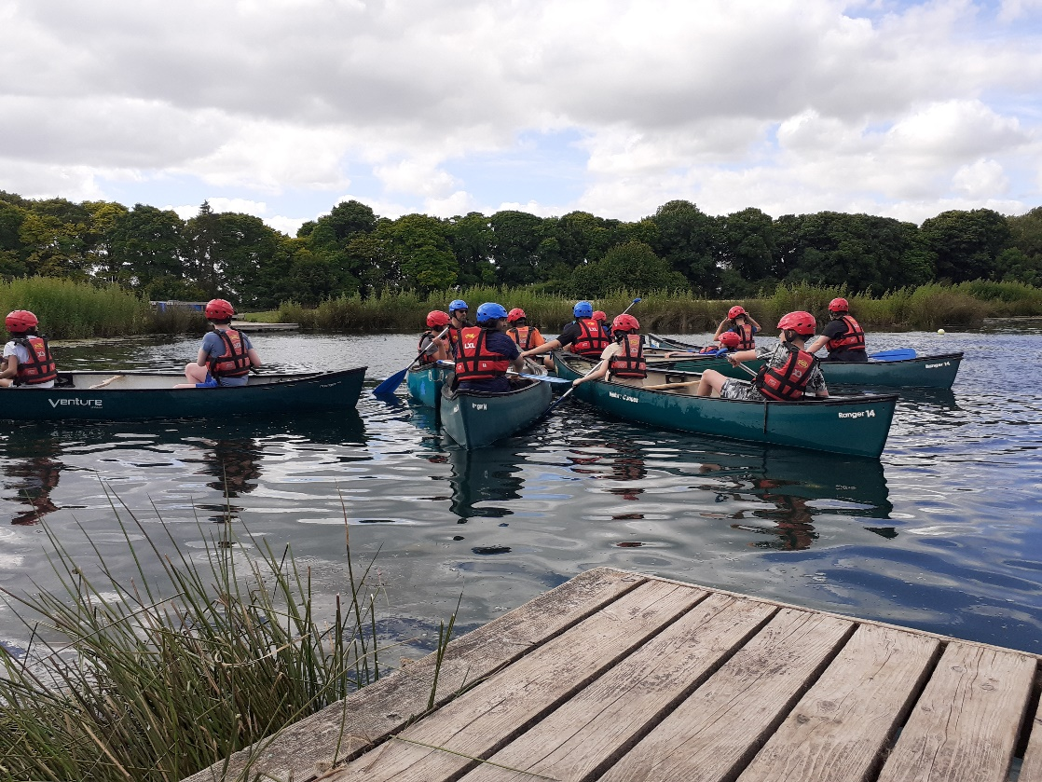

Moving forward
To improve parental engagement, we have increased the number of coffee morning the school will hold and all-day trips have been arranged for each class, which parents will be invited to, funded by the school. Through the all-day trips we hope to improve pupils’ cultural capital by giving them experiences they may not have had before.
We aim to support pupils across all subjects, through staff CPD on adaptive teaching. This should enable all pupils to access and be successful within the curriculum at their appropriate level.
We will improve our staff’s understanding of the English curriculum and it’s implementation through whole-school CPD.
For Maths and English, we will continue to support children who working at least two years below the age-related levels with 1-1 support. This will be focussed on teacher assessment and filling in gaps in prior learning.
The school will also continue its development of Trauma Informed Practices by introducing “Zones of Regulation” education for staff and pupils.
The school will continue to provide different forms of therapy for PPG children.
The school projected it would spend £31,299 and calculated costs were £30,113.24.

Externally provided programmes
Please include the names of any non-DfE programmes that you purchased in the previous academic year. This will help the Department for Education identify which ones are popular in England
Programme | Provider
ELSA | About ELSA – ELSA Network
LEGO Therapy | LEGO Therapy - Online hub for research, resources, training, and conversation for LEGO therapy and autism.

Further information
Planning, implementation, and evaluation

In planning our pupil premium strategy, we looked at a number of reports, studies and research papers about effective use of pupil premium, the impact of disadvantage on education outcomes and how to address challenges to learning presented by socio-economic disadvantage. We used the EEF’s guidance to help us develop our strategy.

