PE & Sport Premium Funding 2024-2025 | 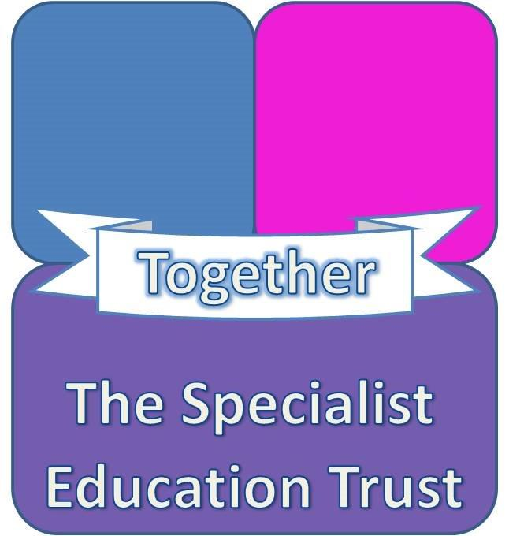
LITTLEDOWN SCHOOL
The PE and Sport premium funding is designed to help primary schools improve the quality of the PE and sport activities they offer their pupils.

Schools must spend the funding to improve the quality of the PE and sport activities they offer their pupils, to give them the opportunity to develop a healthy lifestyle, but they are free to choose the best way of using the money.

The funding is provided by the Departments for Education, Health and Culture, Media and Sport. It is allocated to primary school head teachers. It is allocated for pupils in years 1-6 and for schools with 16 or less pupils it is allocated as £500 per eligible pupil and those with 17 or more pupils it is allocated based on a lump sum of £16,000 and an additional payment of £10 per eligible pupil.

Schools must publish details of how they spend this funding and the effect it has had on pupils’ PE and sport participation and attainment. Ofsted report on how primary schools spend their PE and sport premium funding.

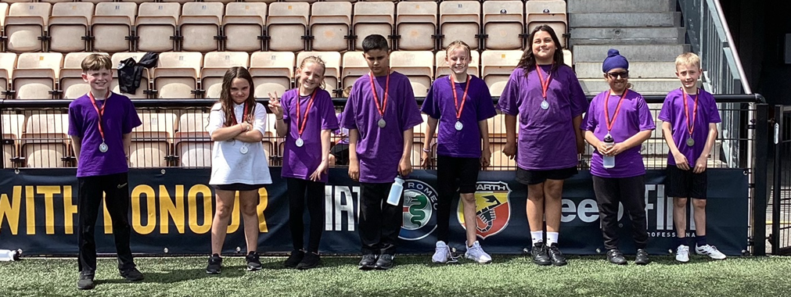 | Funding Allocation
 | Academic year | Pupils | Funding per pupil | Lump Sum | Total Funding
 | 2023-24 | 31 | £10 | £16,000 | £16,310
 | 2024-2025 | 38 | £10 | £16,000 | £16,380
 | Purpose of the Grant
Schools must spend the funding to improve the quality of the PE and sport activities they offer their pupils, but they are free to choose the best way of using the money.
For example, funding can be used to:
•provide existing staff with teaching resources to help them teach PE and sport
•support and involve less active children by running or extending school sports clubs, holiday clubs and Change4Life clubs
•run sport competitions or increase pupils’ participation in the School Games
•run sports activities with other schools
•hire specialist PE teachers
•hire qualified sports coaches to work with teachers.
Build capacity and capability within the school to ensure that improvements made now will benefit pupils joining the school in future years

Resources

Provision of PE and Sport at the School in 2024/2025
Curriculum PE and Sport and sport activities | Enrichment PE and Sport and sport activities | Competitions entered
Ongoing Physical Development programme (afternoons) | Street Dance | New Age Kurling
SSSN Coaching Programme Yoga - 44 hours level 2 NGB | Swimming | Boccia Slough
SSSN Cricket sessions 6 hours | Ice Skating | Speed Stacking
Horse riding sessions 3 hours | Archery | Berkshire games Speed Stacking
SSSN Active movement programme | Bowling | Sports Day
Subject leader training | Horse riding | Football tournament
Swimming sessions 36 hours | Golf | Judo
Ice Skating sessions 3 hours | Golfplex
 | Outdoor pursuits activities (Paccar Scout Camp, Look Out)
 | After school dance

Expenditure
How we have spent it in 2024/25
Slough School Sports Network affiliation | 3380
Street Dance | 2040
Horse Riding | 3400
Golf | 658
Ice Skating | 1,040
Swimming | 898.85
Archery | 90
Go-Karting | 120
Bowling | 154
Swimming training | 685
Ben Pritchard | 300
PE uniform | 650
PE equipment | 500
Total | 13,915.85

Ho
Meeting national curriculum requirements for swimming and water safety 2024/25
What percentage of your current Year 6 cohort swim competently, confidently and proficiently over a distance of at least 25 metres? |  | 16.6% 1/6 pupils
What percentage of your current Year 6 cohort use a range of strokes effectively [for example, front crawl, backstroke and breaststroke? |  | 16.6% 1/6 pupils
What percentage of your current Year 6 cohort perform safe self-rescue in different water-based situations? |  | 66.6% 4/6 pupils
Schools can choose to use the Primary PE and Sport Premium to provide additional provision for swimming but this must be for activity over and above the national curriculum requirements. Have you used it in this way? |  | Yes/No

a

